Think of a number and follow these steps:

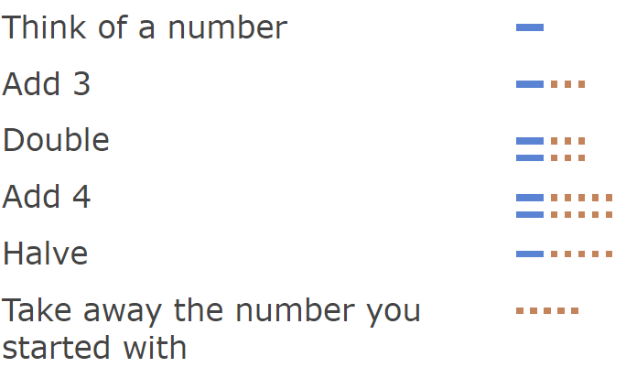
Now try again starting with a different number.
Try again.
Try starting with a fraction... or decimal... or negative number...
Why are your answers ALWAYS the same?
Can you design instructions for similar "Think of a number" machines of your own?
Test them on a partner to check that they lead to your anticipated solutions.

